Web Page: wmata.com/PotomacYard
Hashtags: #PotomacYard #wmata #AlexandriaVA #PotomacYardStation #yourmetro

***
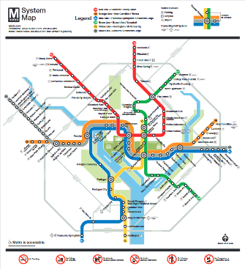

Image: Metro System Map

Sample e-Newsletter Copy:
Metro’s Newest Station is OPEN!
Metro’s Potomac Yard Station is now open! The new station provides additional Metrorail access between Alexandria, Va. and the DC region, offering a gateway to retail, dining, education, job opportunities, and services. This is Metro’s 98th rail station and the second infill station, meaning it is built within an existing rail line. Visit wmata.com/PotomacYard to learn all about how to get to the station, which Metroway and DASH bus routes serve the station, where to park your bike, and more!

***
Sample Social Media Copy:

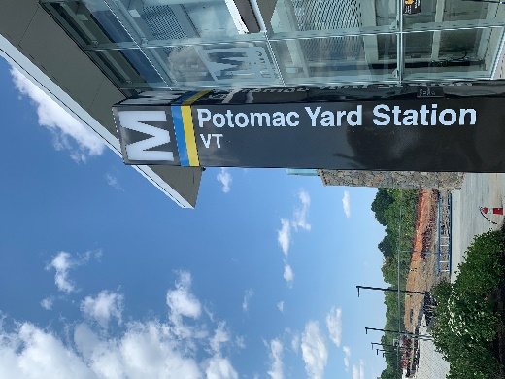

Image: Potomac Yard Pylon

Facebook:
Metro’s newest station, Potomac Yard 🔵🟡, is open! Visit @metroforward’s website to learn more about the newest station, including:
✅Station features
✅ Frequently asked questions

Welcome aboard! Learn more: wmata.com/PotomacYard

Shortened for Twitter:
📢 Metro’s newest station, Potomac Yard 🔵🟡, is OPEN! Visit the @wmata website, wmata.com/PotomacYard to learn all about how to get to the station 🗺️, which bus routes will serve the station 🚍, where to park your bike 🚲, and more! #wmata #PotomacYardStation
***

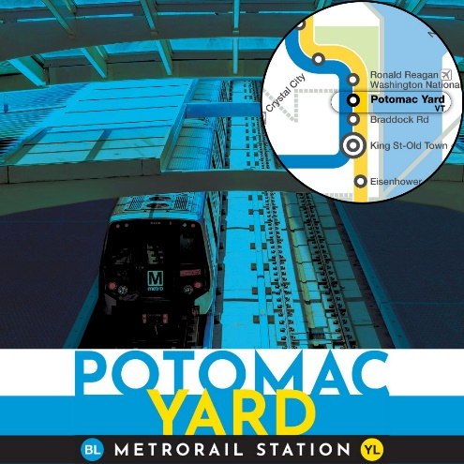
Sample Social Media Copy:

Image: Potomac Yard Image

Facebook: The new Potomac Yard Station serves the Blue 🔵and Yellow 🟡 lines and provides a gateway to @VisitAlexandriaVA and the surrounding communities, including walkable access to retail, jobs, residential & commercial development, and the new @VirginiaTech Innovation Campus! Learn more about @Metroforward’s newest station at wmata.com/PotomacYard

Instagram: Potomac Yard Station serves the Blue 🔵and Yellow 🟡 lines and provides a gateway to @VisitAlexVA and the surrounding communities, including walkable access to retail, jobs, residential & commercial development, and the new @Virginia.Tech Innovation Campus! Learn more about @Metroforward’s newest station by visiting their website!

Twitter: Potomac Yard Station serves the Blue 🔵and Yellow 🟡 lines and provides a gateway to @AlexandriaVA and the surrounding communities, including walkable access to retail, jobs, residential & commercial development, and the new @Virginia_Tech Innovation Campus! wmata.com/PotomacYard

