**Overview:**

Thank you for helping to spread the word about Metro’s Summer 2025 major construction projects. Please feel free to use or adapt the sample material below.

**Web pages:**

[Wmata.com/majorconstruction](http://www.wmata.com/majorconstruction)

[Wmata.com/phase1](https://wmata.com/phase1)

**Hashtags:**

#wmata #YourMetro #metrorail

**Sample e-Newsletter copy:**

Upcoming Service Changes: Major Construction on the Blue Line, July 5-26

[Starting July 5, 2025,](https://youtu.be/purL3ivC1Gw) Metro will close select stations on the Blue Line for three weeks of construction projects to improve tracks and signaling and enhance your ride.

**Key Details:**

* **July 5-26:** Franconia-Springfield and Van Dorn St stations will be closed.
  + Parking will be free at these stations.
  + VRE will remain open during this time.
* **July 12-13 and 19-20:** Yellow Line will single-track between Huntington and Braddock Rd stations.
* **July 27:** Blue Line stations will reopen on July 27

During the closure, **free shuttle buses** will replace train service at the impacted stations. The project includes vital work such as replacing fasteners, welding joints, upgrading platform lighting and more. The timing minimizes disruption by taking advantage of typically lower ridership. This extended closure reduces the need for multiple weekend shutdowns.

[Stay informed](https://wmata.com/initiatives/plans/summer-2025-major-construction/phase-1-2025-blue-line-major-construction.cfm) and plan your trips accordingly.

**Social media channels to follow**:

* **X**: @wmata, @metrorailinfo, @metrobusinfo
* **Facebook**: Metro Forward
* **Instagram**: Metro Forward

**Sample Social Media Posts**

**X/Twitter:**

Blue Line Customers: Major construction will impact Franconia-Springfield and Van Dorn St stations from July 5-26. Free shuttles will replace trains. Get the details: [wmata.com/majorconstruction](https://wmata.com/majorconstruction) #wmata

**Instagram/Facebook**:

Blue Line Customers: Starting July 5, Metro will begin major maintenance work at Franconia-Springfield and Van Dorn St stations through July 26. This project will improve tracks and signaling for a smoother, safer ride.

Free shuttle buses will replace trains during the closure, and stations will reopen on July 27. Plan ahead and check [wmata.com/majorconstruction](https://wmata.com/majorconstruction) for all the details, including shuttle bus information and travel alternatives. #wmata #YourMetro

**Service Alert Videos:**

* [English](https://youtu.be/purL3ivC1Gw)
* [Spanish](https://youtu.be/Glpsdv9neb4)

**Graphics (system & shuttle bus maps)**

**System Map July 5-26**

**English**

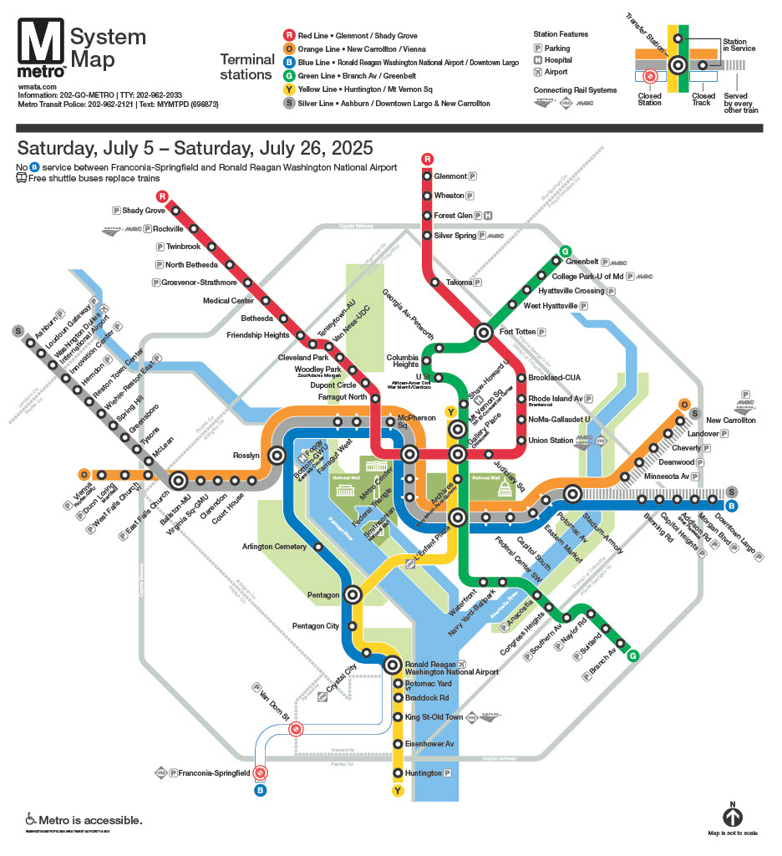

**Spanish**

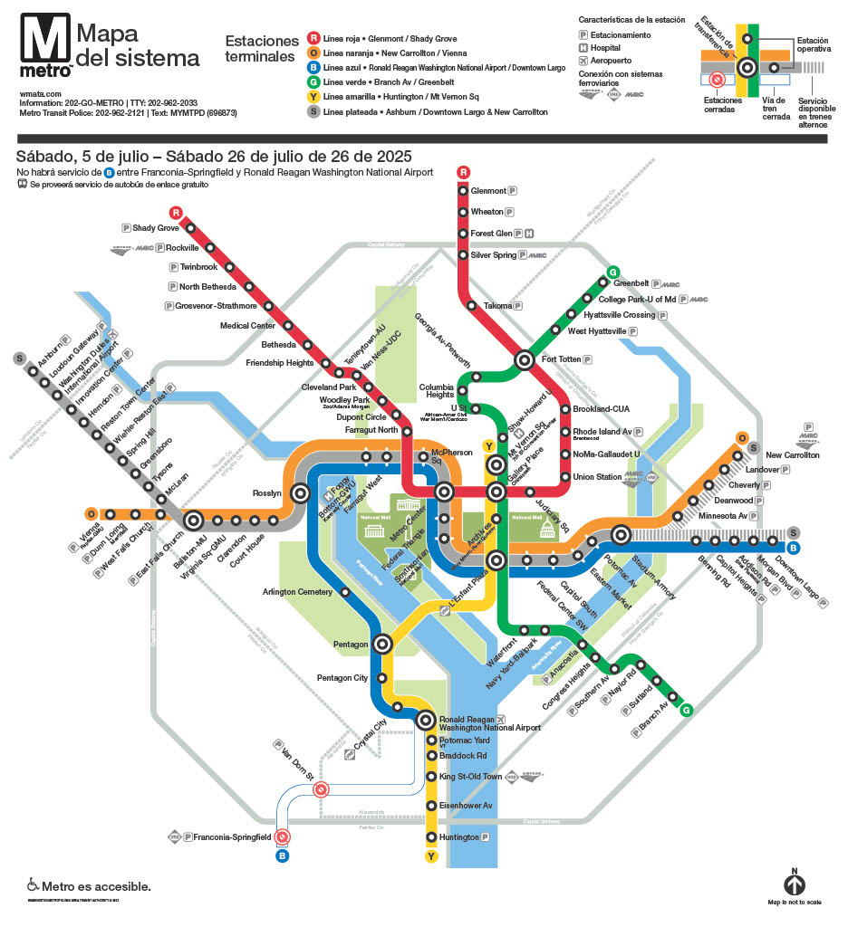

**Shuttle bus map July 5-26**

**English**

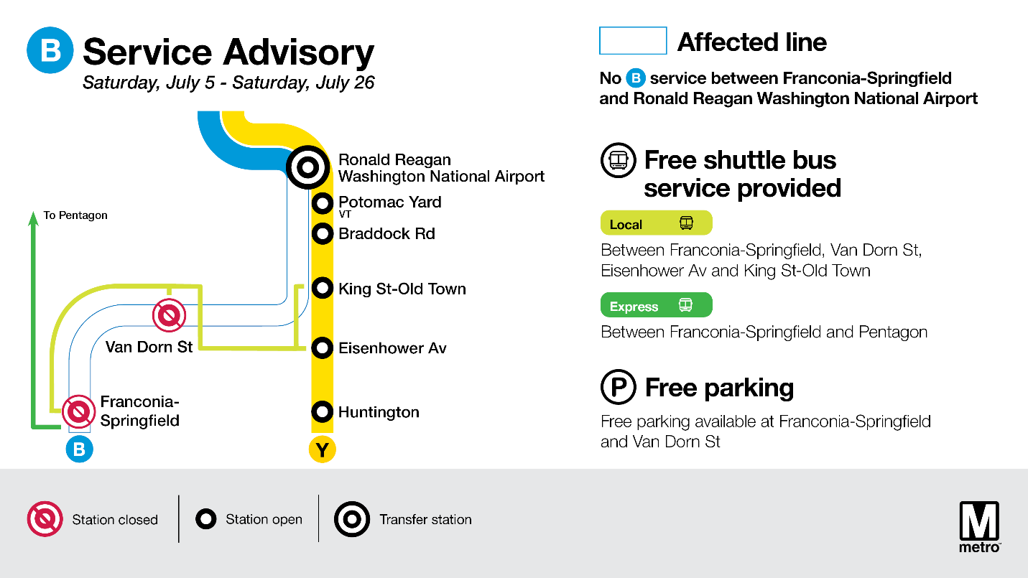**Spanish**

