**Overview:**

Thank you for helping to spread the word about Metro’s Summer 2025 major construction projects. Please feel free to adapt or use the sample material below.

**Web pages:**

[Wmata.com/majorconstruction](http://www.wmata.com/majorconstruction)

[Wmata.com/phase2](https://wmata.com/phase2)

**Hashtags:**

#wmata #YourMetro #metrorail

**Sample e-Newsletter copy:**

Upcoming Service Changes: Major Construction on the Green Line, Aug. 2-31

[Starting August 2, 2025](https://www.youtube.com/watch?v=V_9xiP9Jv5E), Metro will close select stations on the Green Line for four weeks of construction projects to improve tracks and signaling and enhance your ride.Aug. 2, 2025, Metro will close select stations on the Green Line for four weeks of construction projects to improve tracks and signaling and enhance your ride.

**Key Details:**

* **Aug. 2-31:** Branch Ave, Suitland, and Naylor Road stations will be closed.
  + Parking will be free at these stations.
* **Aug.** **9-10 and Aug. 16-17:** Southern Ave and Congress Heights stations will also be closed.
* **September 1:** Green Line stations will reopen on Sept. 1, 2025.

During the closure, **free shuttle buses** will replace train service at impacted stations. The project includes vital work such as installing new radio and fiber-optic cables for communication and train control systems, renewing and maintaining rail, and upgrading platform lighting, among other improvements. The timing minimizes disruption by taking advantage of a time of year with typically lower ridership. This extended closure reduces the need for multiple weekend shutdowns.

[Stay informed](https://www.wmata.com/initiatives/plans/summer-2025-major-construction/phase-2-2025-green-line-major-construction.cfm) and plan your trips accordingly.

**Social media channels to follow**:

* **X**: @wmata, @metrorailinfo, @metrobusinfo
* **Facebook**: Metro Forward
* **Instagram**: Metro Forward

**Sample Social Media Posts**

**X/Twitter:**

Green Line Customers: Major construction will impact Branch Ave, Suitland, and Naylor Road stations from Aug. 2-31. Free shuttles will replace trains. Get the details: [wmata.com/majorconstruction](https://wmata.com/majorconstruction) #wmata

**X/Twitter:**

Green Line Customers: Ongoing major construction will extend to Southern Ave and Congress Heights stations on the weekends of Aug. 9-10 and Aug. 16-17. Free shuttles will replace trains. Get the details: [wmata.com/majorconstruction](https://wmata.com/majorconstruction) #wmata

**Instagram/Facebook**:

Green Line Customers: Starting Aug. 2, Metro will begin major maintenance work at Branch Ave, Suitland, and Naylor Road stations through Aug. 31. This project will improve tracks and signaling for a smoother, safer ride.

Free shuttle buses will replace trains during the closure, and stations will reopen on Aug. 31. Plan ahead and check [wmata.com/majorconstruction](https://wmata.com/majorconstruction) for all the details, including shuttle bus information and travel alternatives. #wmata #YourMetro

**Instagram/Facebook**:

Green Line Customers: Over two weekends, Aug. 9-10 and Aug. 16-17, Metro’s ongoing major construction maintenance work will extend to Southern Ave and Congress Heights stations. This project will improve tracks and signaling for a smoother, safer ride.

Free shuttle buses will replace trains during the closure, and these two stations will reopen on Aug. 18. Plan ahead and check [wmata.com/majorconstruction](https://wmata.com/majorconstruction) for all the details, including shuttle bus information and travel alternatives. #wmata #YourMetro

**Service Alert Videos:**

* [English](https://www.youtube.com/watch?v=V_9xiP9Jv5E)
* [Spanish](https://www.youtube.com/watch?v=ZrMsvtrAN5c)

**Graphics (system & shuttle bus maps)**

**System Map Aug.**  **2-31**

**English**

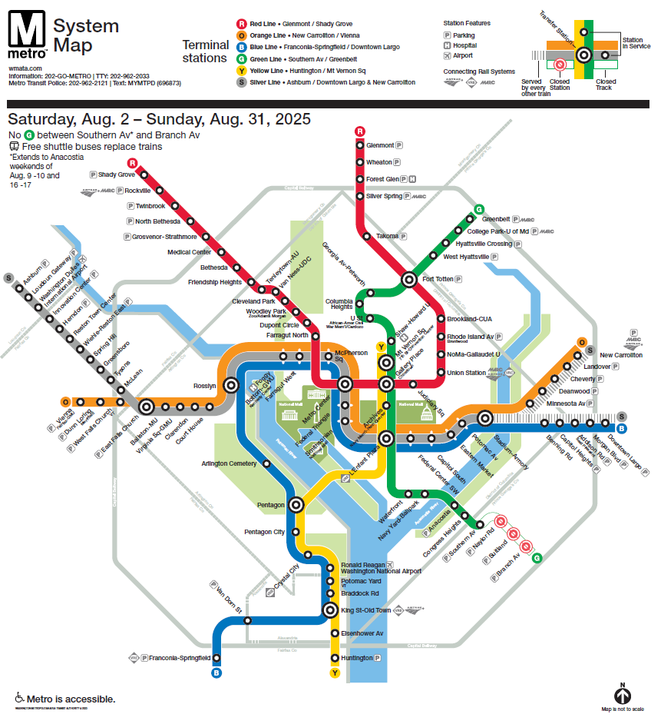

**Spanish**



**System Map Aug. 9-10 and 16-17**

**English**

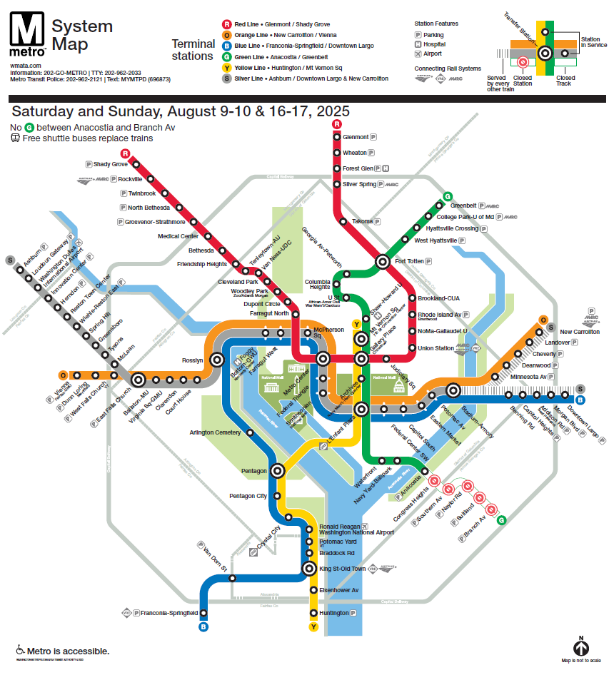

**Spanish**

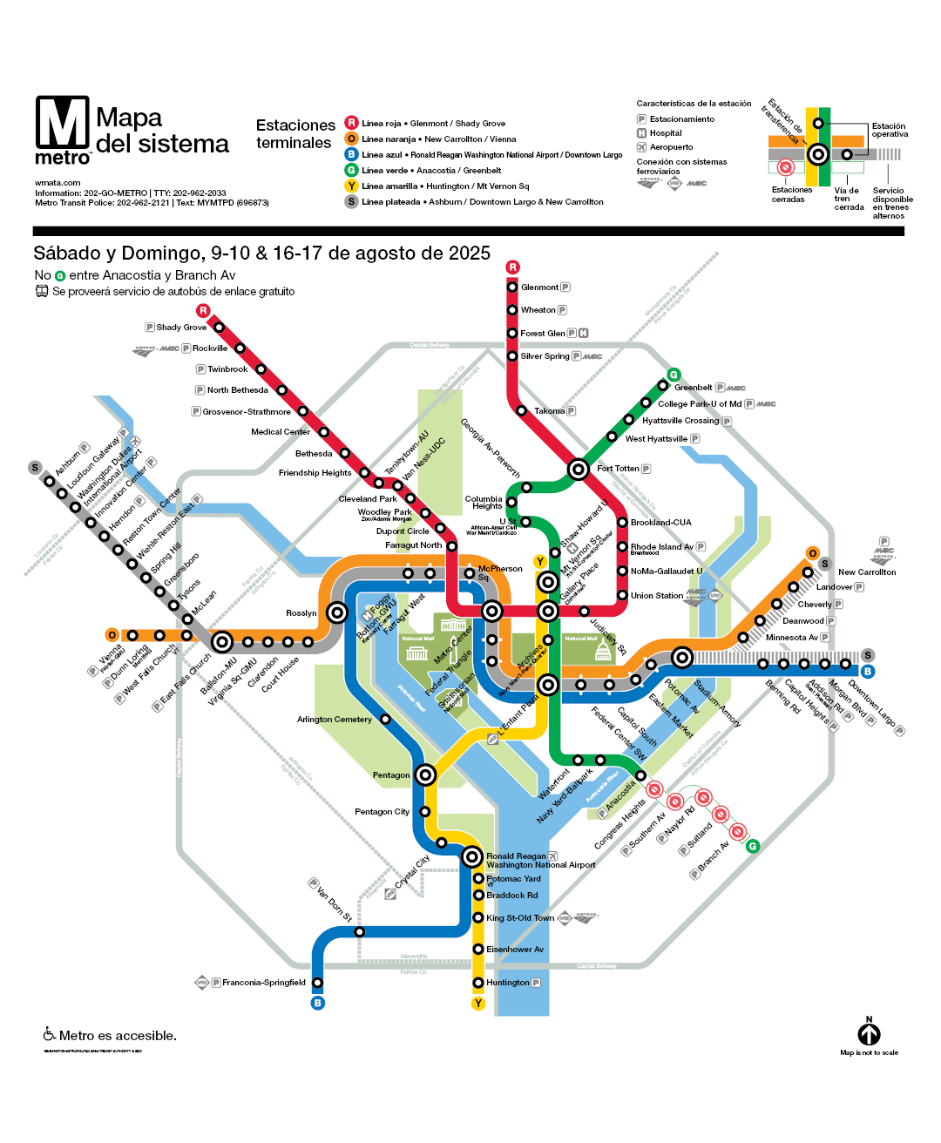

**Shuttle bus map Aug.**  **2-31**

**English**

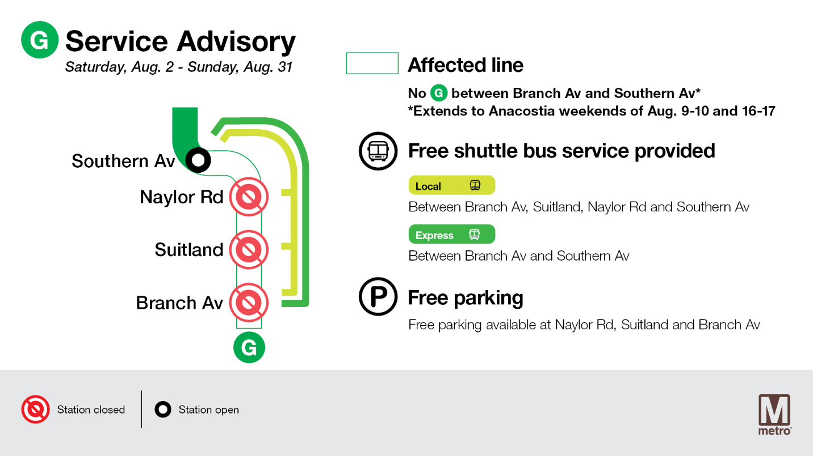**Spanish**

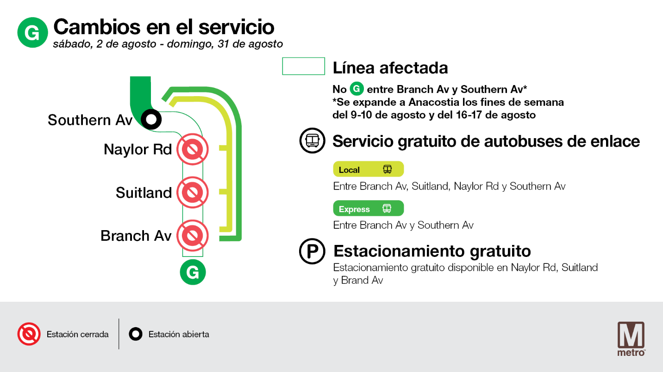

**Shuttle bus map Aug.**  **9-10 and Aug.**  **16-17**

**English**

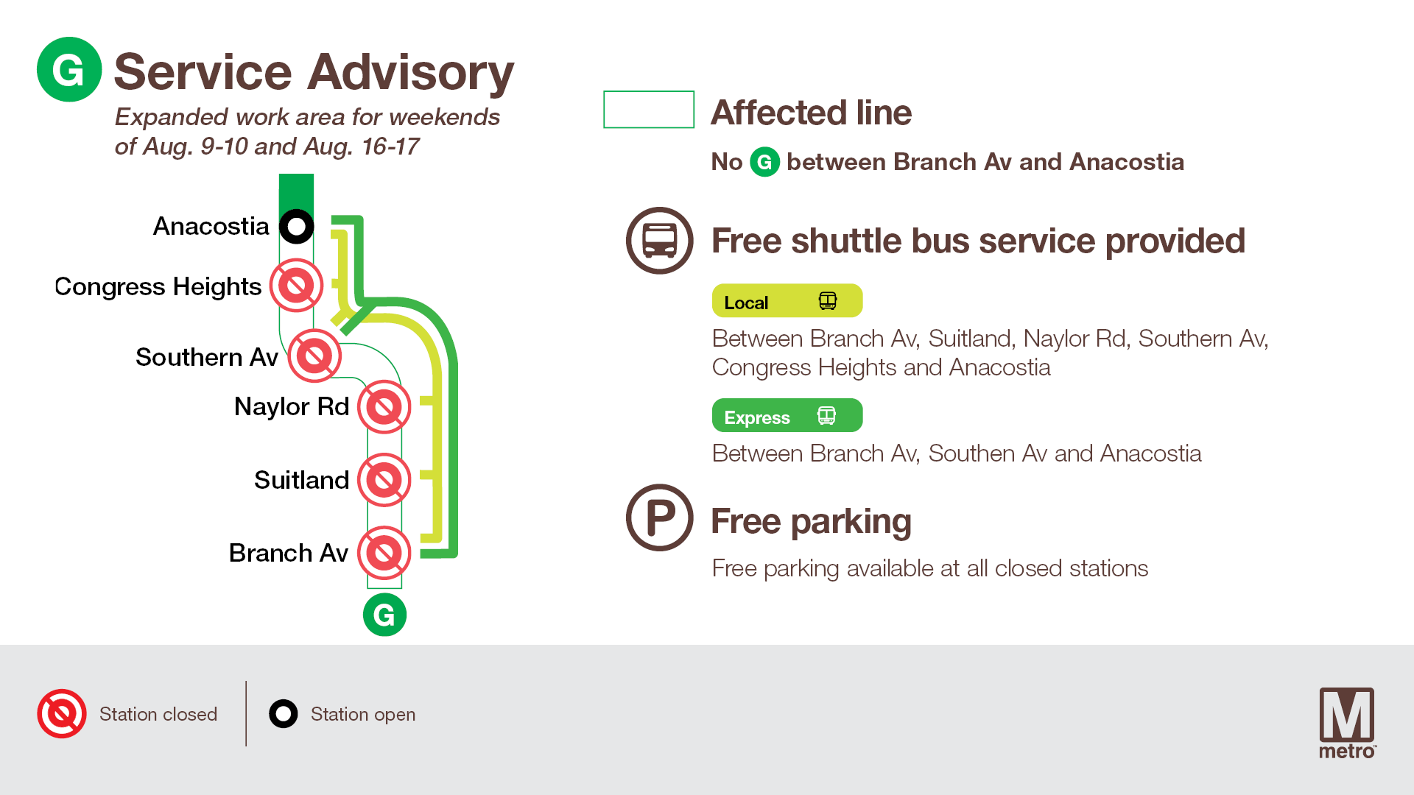

**Spanish**

